Report Type: Study Session

Example Earth Day Staff Report
(Prepared by C/CAG for cities)

DATE:

TO:

FROM: ____________

SUBJECT: Earth Day 2015 Staff Report – Update on Climate Action Plan

Recommendation
This is an informational report and requires no Council action.

Summary
The City /Town of _____________ adopted a Climate Action Plan (CAP) on Month XX, 20XX. The development and adoption of the CAP was the result of careful consideration of costs, benefits, and other priorities of the city/town.

The CAP sets a goal of a XX% reduction of greenhouse gas (GHG) emissions using a baseline year of 20XX. The process of developing a CAP requires establishing a baseline GHG emissions inventory, setting a target reduction, and developing a “business as usual” trend line into the future using variables such as projected population growth. Finally, GHG emissions reduction measures are selected to meet the target reduction.

Since adoption of the city’s CAP, staff has worked with both internal and external stakeholders to implement the XX measures, of which XX have been actively pursued, XX have been completed, and XX have been put on hold due to funding of __________. This progress report serves as an update to both progress towards the measures and the target reduction of GHG emissions.

Overview
The City/Town of __________ is a [give background on what makes your city/town special in terms of the community, livability, trend setting, etc.]. Actions to reduce GHG emissions are an opportunity to further improve the quality of life for residents, employers and visitors to our city/town. The CAP will assist the City/Town of ____ meet or exceed the emissions reduction targets of AB 32 (California’s Global Warming Solutions Act of 2006). AB 32 sets a goal for the state to reduce greenhouse gas emissions to 1990 levels by 2020 and 80% below 1990 levels by 2050. In addition, the City/Town of ________ is part of a regional initiative to work together with cities across San Mateo County to address climate change issues. The City and County Association of Governments of San Mateo County (C/CAG) endeavors to take a countywide approach to reducing use of resources and their associated GHG emissions. Through the C/CAG Regionally Integrated Climate Action Planning Suite (RICAPS) program, the City/Town of ___________ works collaboratively with neighboring jurisdictions to implement GHG emission reduction programs and measures and track GHG emissions communitywide on an annual basis.

Since adoption of its CAP, the city/town has implemented [give examples of projects related to GHG emissions at city buildings and its fleet], has [give examples of residential energy efficiency improvements], has [give examples of improvements in the commercial sector], and has [give examples of reduction efforts in the solid waste sector]. These actions have had the effect of reducing emissions, but the City/Town of ______ will continue to work to meet the goals of our CAP.

Progress Report

Government Operations: Agency Greenhouse Gas, Electricity and Natural Gas Reductions

Staff recently completed a GHG emission inventory for the City/Town of ___________’s government operations.

The inventory shows that the City (is/is not) on track to meet the overall GHG reduction target of XX% against the baseline year of 20XX by 20XX, but/and additional action is needed to continue on the trajectory towards the target. The full implementation of the measures listed below is expected to continue moving the City/Town of ___________towards achieving the reduction target.

Table 1. Summary of Government Operations Greenhouse Gas Emissions
Sector | 2005 Baseline GHG Emissions  (metric tons CO₂e) | 20XX GHG Emissions  (metric tons CO₂e) | Percent Change  (%)
Employee Commute | XX | XX | XX
Buildings and Facilities | XX | XX | XX
Vehicle Fleet | XX | XX | XX
Wastewater | XX | XX | XX
Government-Generated Solid Waste | XX | XX | XX
Water Transport | XX | XX | XX
Public Lighting | XX | XX | XX
TOTAL | X,XXX | X,XXX | XX

Description of electricity and natural gas savings projects since base year:
- Project name and description, year completed and estimated annual savings

Community Greenhouse Gas Reductions and Energy Efficiency Activities

With assistance from C/CAG, staff recently completed an updated community GHG emission inventory for the City/Town of ___________. The inventory shows that the city/town (is/is not) on track to meet the overall GHG reduction target of XX% against the baseline year of 20XX by 20XX. The full implementation of the climate action plan measures listed below is expected to continue moving the City/Town of ___________towards achieving the reduction targets.

Table 2. Summary of Community Greenhouse Gas Emissions
Sector | 2005 Baseline GHG Emissions  (metric tons CO₂e) | 20XX GHG Emissions  (metric tons CO₂e) | Percent Change  (%)
Residential | XX | XX | XX
Commercial/Industrial | XX | XX | XX
Stationary Sources | Not included | XX | Not applicable
Transportation – Local Roads | XX | XX | XX
Transportation – State Highways | XX | XX | XX
Transportation – Off-road Equipment | XX | XX | XX
Transportation – Caltrain and Freight Trains | Not included | XX | Not applicable
Generated Waste | XX | XX | XX
Landfills | XX | XX | XX
Wastewater | Not included | XX | Not applicable
Water | Not included | XX | Not applicable
TOTAL | X,XXX | X,XXX | XX

Figure 1. Community Emissions by Sector in 2010
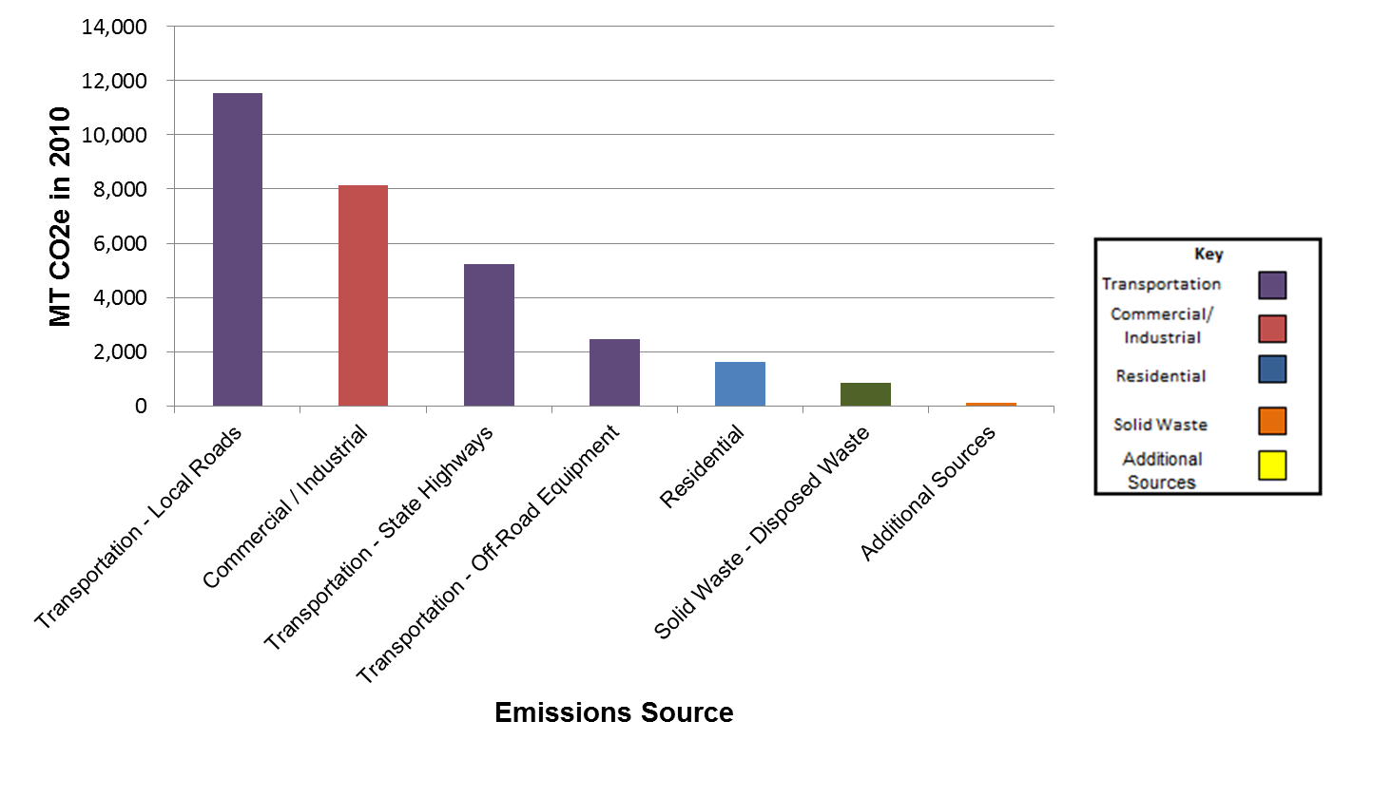
[This graph can be pulled from your city’s Community GHG Inventory Excel workbook]

Description of activities promoting energy efficiency in the community:
- [One-paragraph examples include: Launching a small business outreach campaign as part of SMCEW, PACE, Environmental Affairs Facebook Page, Earth Day Festival, etc… pull out programs included in the Climate Action Plan]

Climate Action Plan Progress Update

In Month XX, 20XX, the City/Town of _____________ adopted a climate action plan (CAP) to serve as a roadmap for greenhouse gas emissions communitywide. The CAP sets a goal of reducing GHG emissions XX% below 2005 by 20XX. The development and adoption of the CAP was the result of careful consideration of costs, benefits, and other priorities of the City.

Since adoption of the city’s CAP, staff has worked with both internal and external stakeholders to implement the XX measures, of which XX have been actively pursued, XX have been completed, and XX have been put on hold due to funding of __________. This progress report serves as an update to both progress towards the measures and the target reduction of GHG emissions.

City/Town of ______________’s CAP measures and progress are shown in Table 3 below.

Table 3. Overview of Climate Action Plan Measures and Status
Measure Number | Measure Name | Measure Description | Measure Status
EC1 | Energy efficiency in the residential sector | Encourage residents and multifamily building owners to retrofit homes and apartments/condos to more efficient standards | “Not Implemented” or “Progress Initiated” or “Implementation Complete”

Modifications to Climate Action Plan

Since the City/Town of ________ adopted the adopted the CAP, _______measures have been modified. [In this section, describe any changes to specific CAP measures since the CAP was implemented and relevant driving factors behind these changes].

Beacon Award Program 10 Best Practice Areas

In this section, we outline the activities underway by the City/Town of ________ according to sustainability best practices published by the Institute for Local Governance’s Beacon Award Program. In XXXX, City Council passed a resolution to participate in the program to guide our community’s sustainability efforts.

- Energy Efficiency & Conservation
- [Provide one example in each category for Silver Beacon Spotlight Awards, 2 examples for Gold Beacon Spotlight Awards and 3 examples for Platinum Beacon Spotlight Awards] – a one paragraph summary is sufficient

- Water & Wastewater
- [Provide one example in each category for Silver, 2 examples for Gold and 3 examples for Platinum] – a one paragraph summary is sufficient

- Green Building
- [Provide one example in each category for Silver, 2 examples for Gold and 3 examples for Platinum] – a one paragraph summary is sufficient

- Waste Reduction & Recycling
- [Provide one example in each category for Silver, 2 examples for Gold and 3 examples for Platinum] – a one paragraph summary is sufficient

- Climate-Friendly Purchasing
- [Provide one example in each category for Silver, 2 examples for Gold and 3 examples for Platinum] – a one paragraph summary is sufficient

- Renewable Energy & Low-Carbon Fuels
- [Provide one example in each category for Silver, 2 examples for Gold and 3 examples for Platinum] – a one paragraph summary is sufficient

- Efficient Transportation
- [Provide one example in each category for Silver, 2 examples for Gold and 3 examples for Platinum] – a one paragraph summary is sufficient

- Land Use & Community Design
- [Provide one example in each category for Silver, 2 examples for Gold and 3 examples for Platinum] – a one paragraph summary is sufficient

- Open Space & Offsetting Carbon Emissions
- [Provide one example in each category for Silver, 2 examples for Gold and 3 examples for Platinum] – a one paragraph summary is sufficient

- Community & Individual Action
- [Provide one example in each category for Silver, 2 examples for Gold and 3 examples for Platinum] – a one paragraph summary is sufficient

Conclusion
The City/Town of ____________ continues to make considerable progress to reduce greenhouse gas emissions in ways that improve quality of life, build prosperity and improve resilience for our community and future generations. Climate change is a global problem and only through local solutions designed to meet the needs of our community can we mitigate and adapt to its impacts and protect the environment. Achieving our community’s sustainability vision will be the result of many people, businesses, and organizations tacking action every day, at home, at work and at play.

